H2 console.

1. Enter the following line in the application.properties file:
   1. Spring.h2.console.enable=true
2. Restart the server i.e. run Spring5webappApplication.
3. Look for the following lines in the console log to get the database name for this session:
4. main] o.s.b.a.h2.H2ConsoleAutoConfiguration : H2 console available at '/h2-console'. Database available at '**jdbc:h2:mem:c2eff049-bffe-4fb6-9977-0b0a00ed00e1'**

This is the database name, copy and paste into the JDBC URL as shown below

1. Start your browser and enter the following:

//http:localhost:8080/h2-console

No password required.

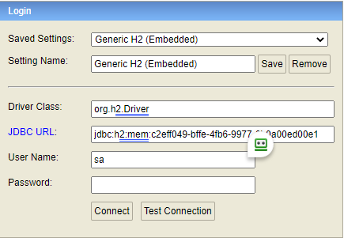

**Spring MVC**

**Spring Framework’s Web Module**

MVC stands for Model View Controller

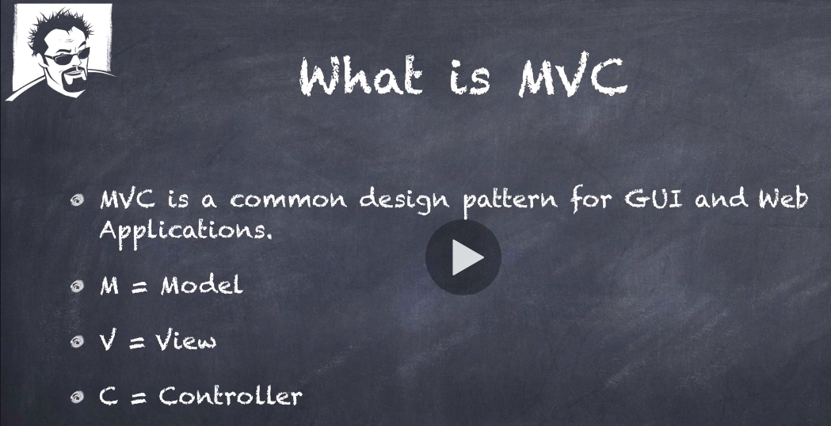

MVC is not unique to Sprint and versions of it is used throughout the development languages and their frameworks.

**Spring MVC**

**Spring Framework’s Web Module**

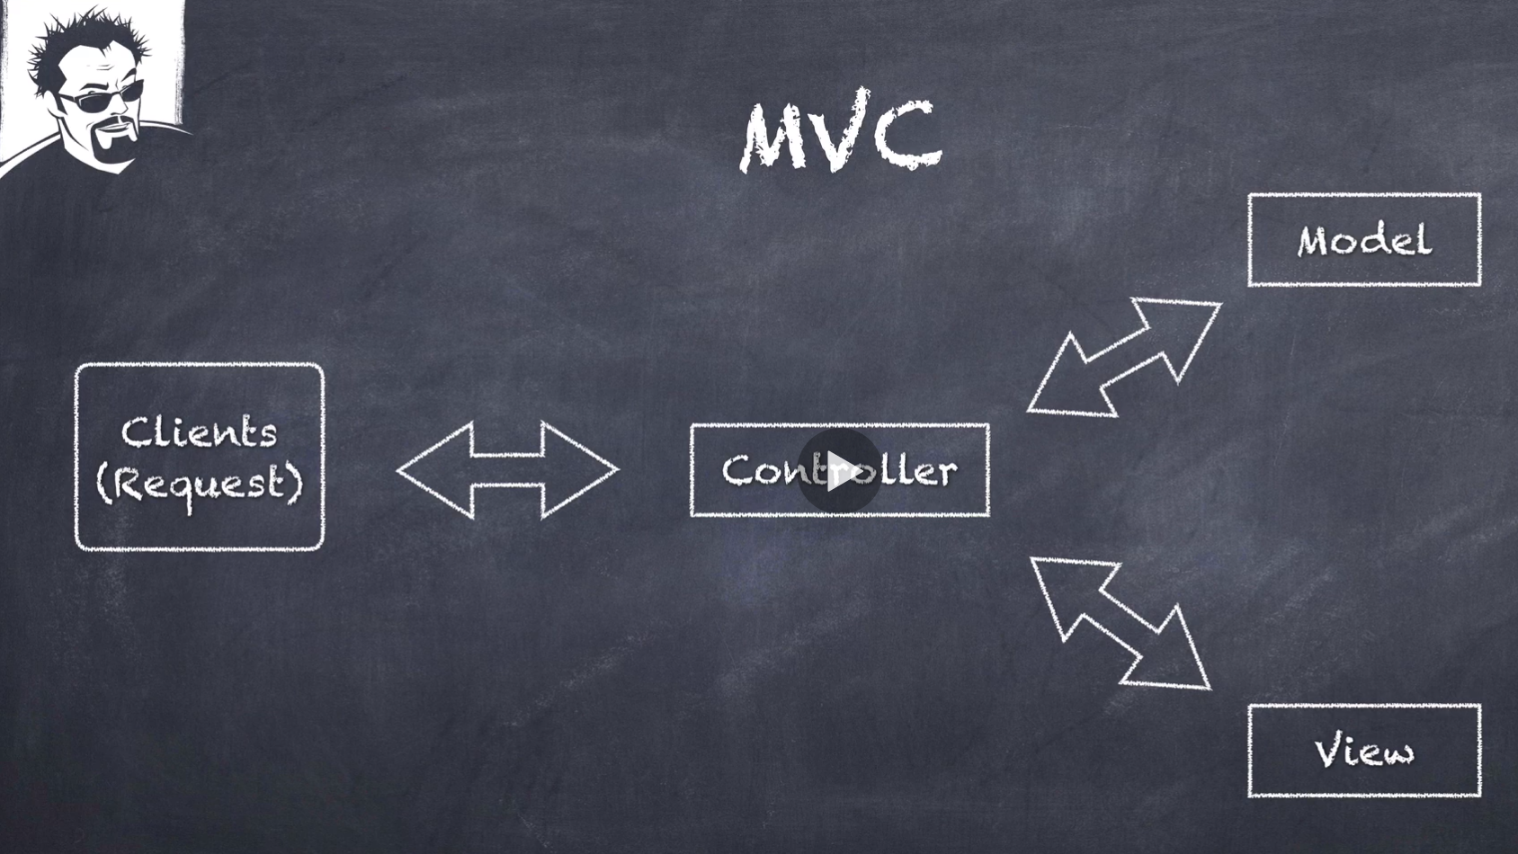

The controller gets the clients request, determines the model, and passes that onto the view.

The model should not contain any business logic, it should just be a data structure.

The Controller is a traffic cop deciding how to get the model who to ask the model from. Keep the Controller light.

The Controller is going to return the model to a view component.

The view component its purpose is to render the view for the client.

We are going to be using Thymeleaf templating engine to create the view, Thymeleaf is going to be taking the model (a POJO) and generates the HTML to return to the client.

**Spring MVC**

**Spring Framework’s Web Module**

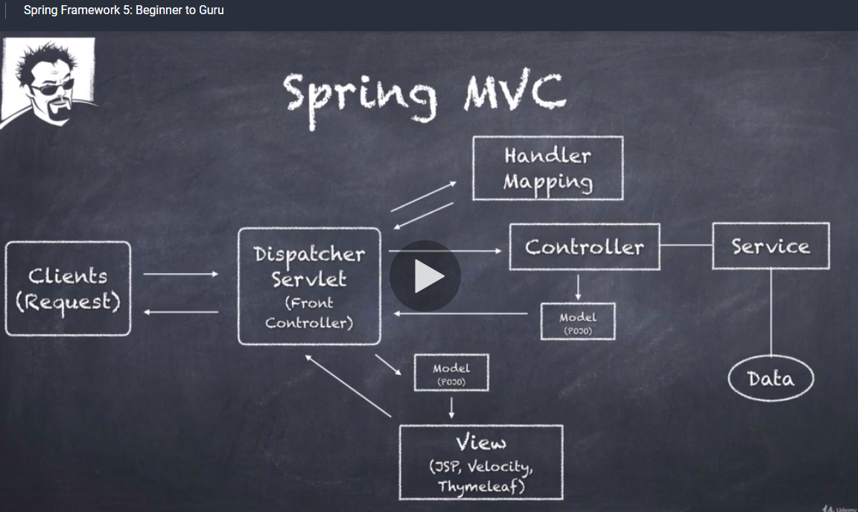

Now looking at MVC purely from a Sprint context.

1. Client request comes in, typically http, it could be for a web page or a REST services control.
2. The Dispatcher Servlet receives the request. It decides how to handle it and it refers to the Handler Mapping because you are going to a specific path and making a request from the server so it says now where do I go for this.
3. The Handler Mapping determines the controller to be utilised and passes that back to The Dispatcher Servlet.
4. The Controller is typically going to have a service layer wired up to it.
5. The service layer is going to get the data and return it back to the controller.
6. The controller is going to take that data, the model which is just a simple POJO and that is returned to the Dispatcher Servlet.
7. In this case the Dispatcher Servlet knows what it wants to do for the view, it could be a Rest call and would return back xml or json, it could be for HTTP HTML and in that case we are going to invoke view a technology to render HTML such as JSP, Velocity or Thymeleaf. The HTML is then rendered back to the client.

Spring Controllers

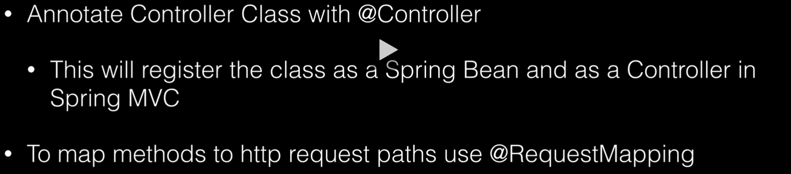

Introducing Thymeleaf

Pronounced (timeleaf)

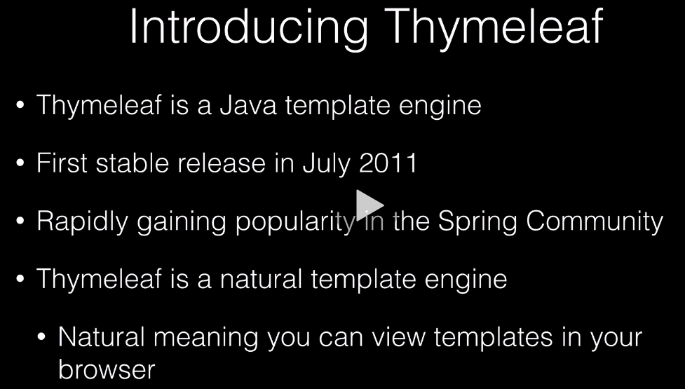

It is an alternative to Java Server Pages (JSP).

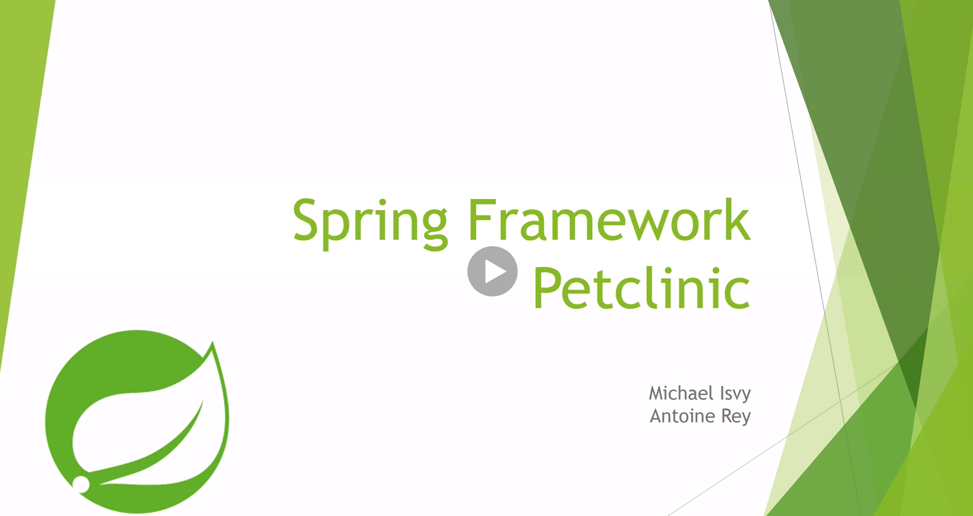

There are some outdated references on this, but it is an example.

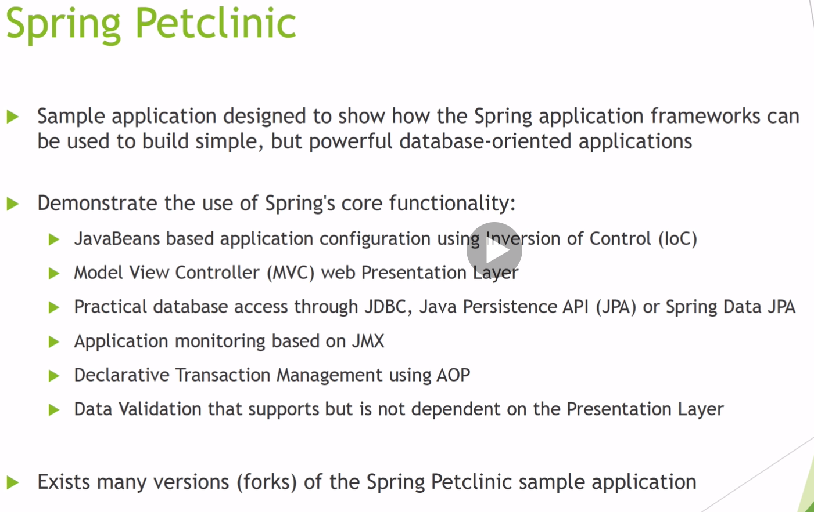

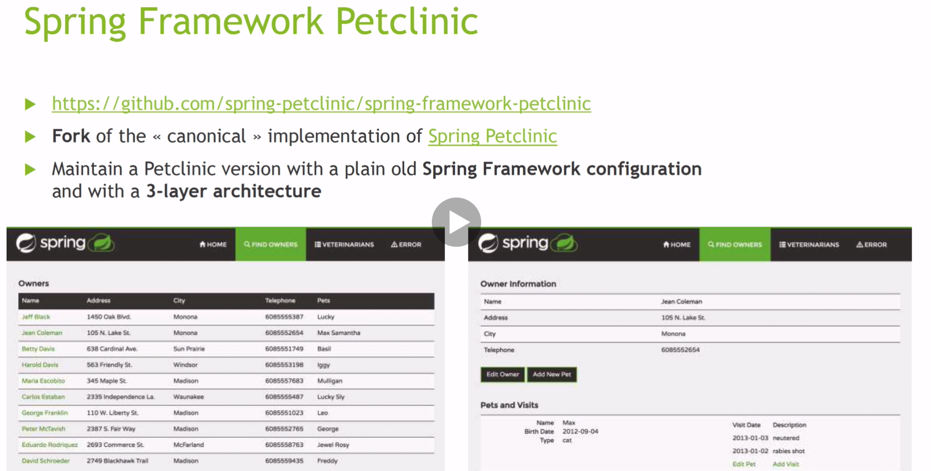

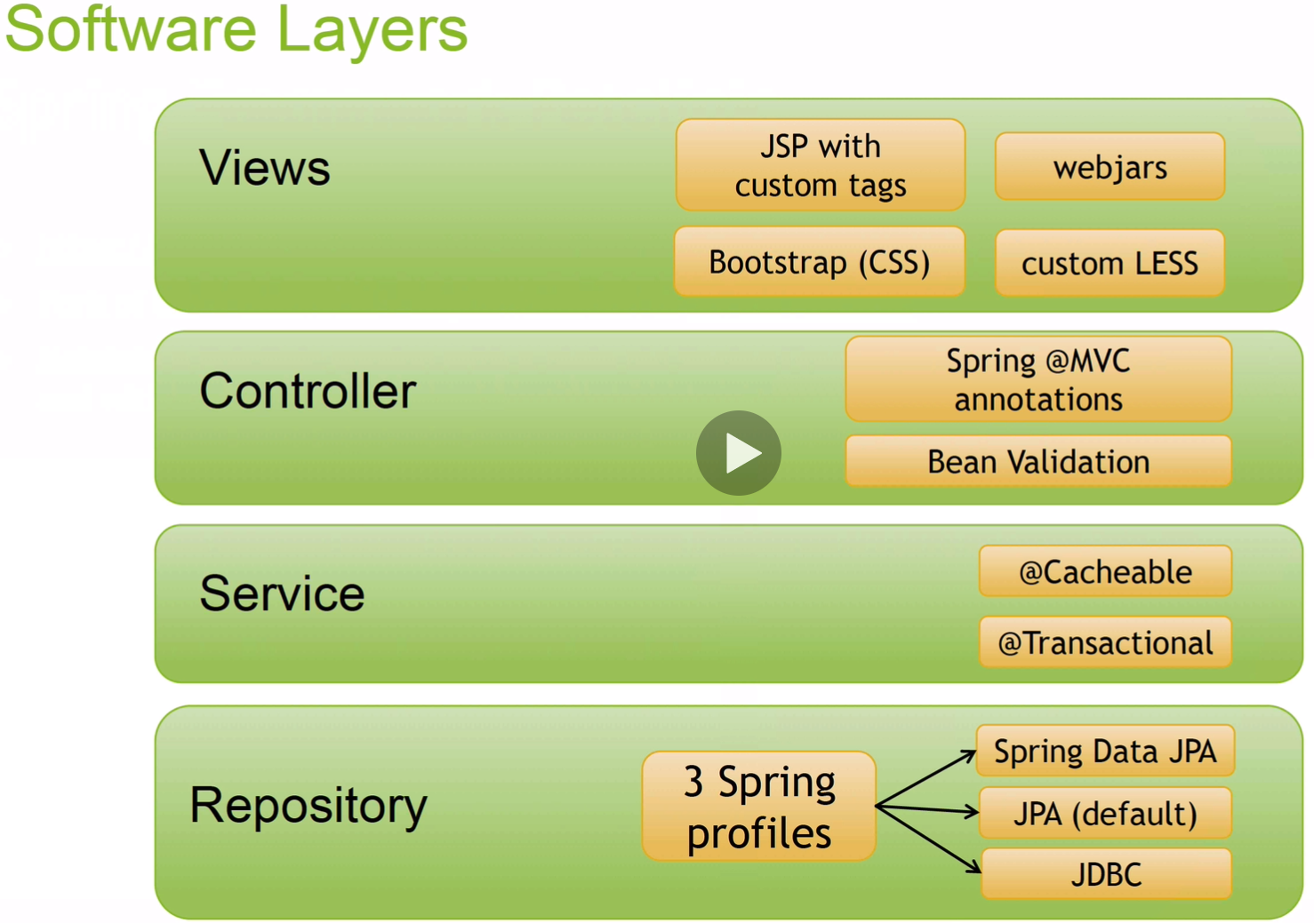

We will be using Thymeleaf and not JSP’s

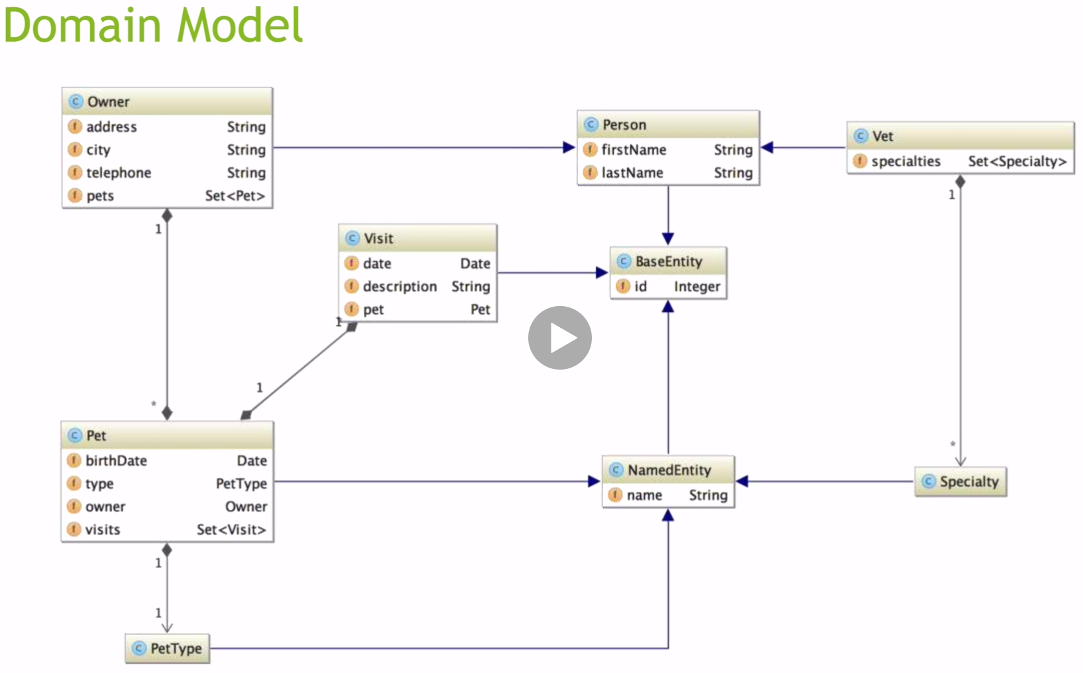

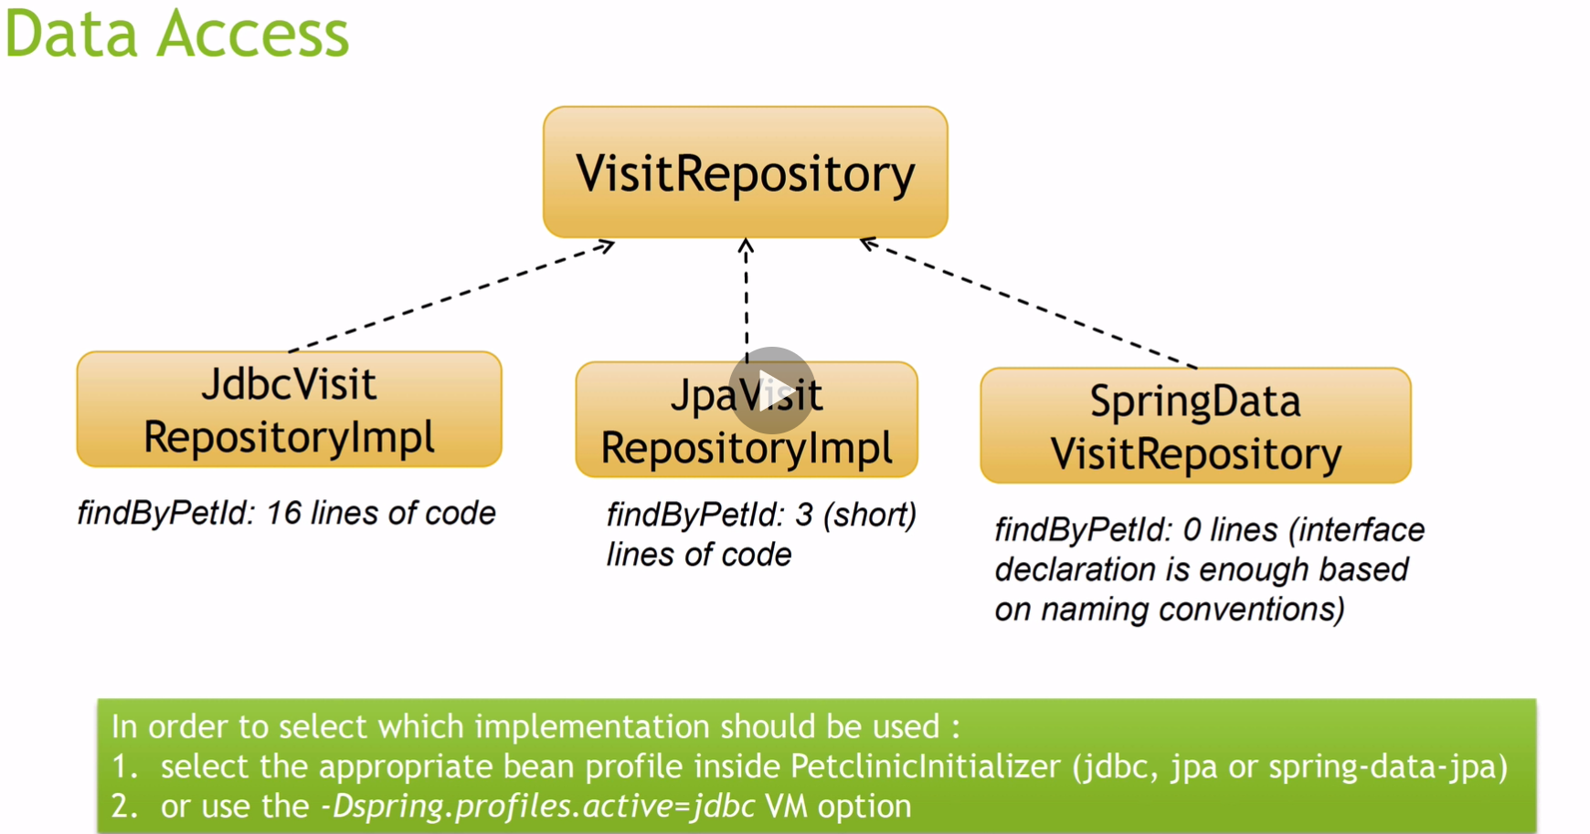

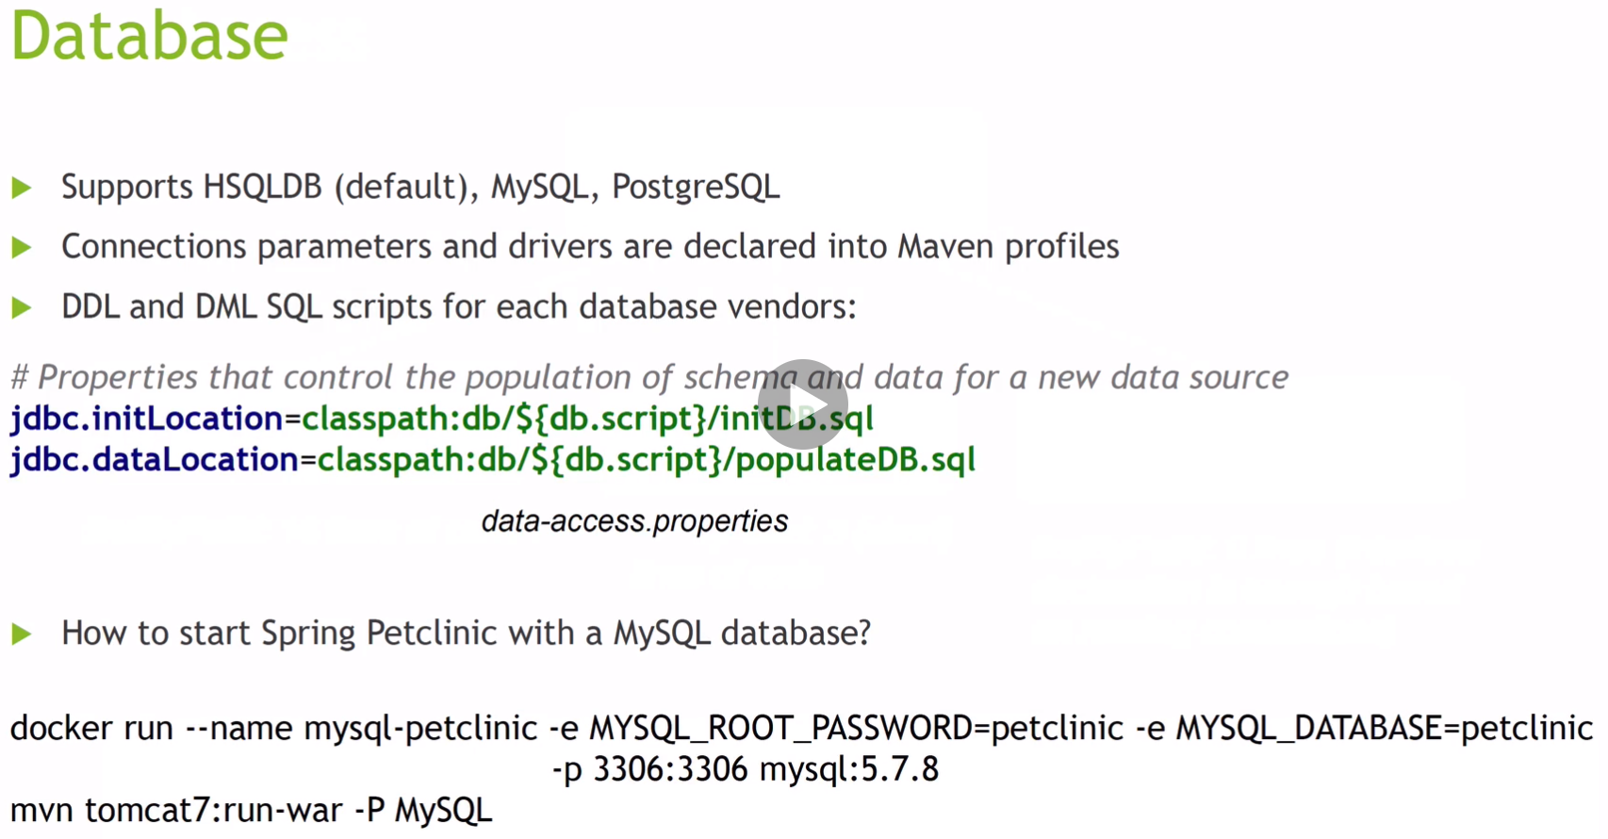

We will be using the h2 memory database.

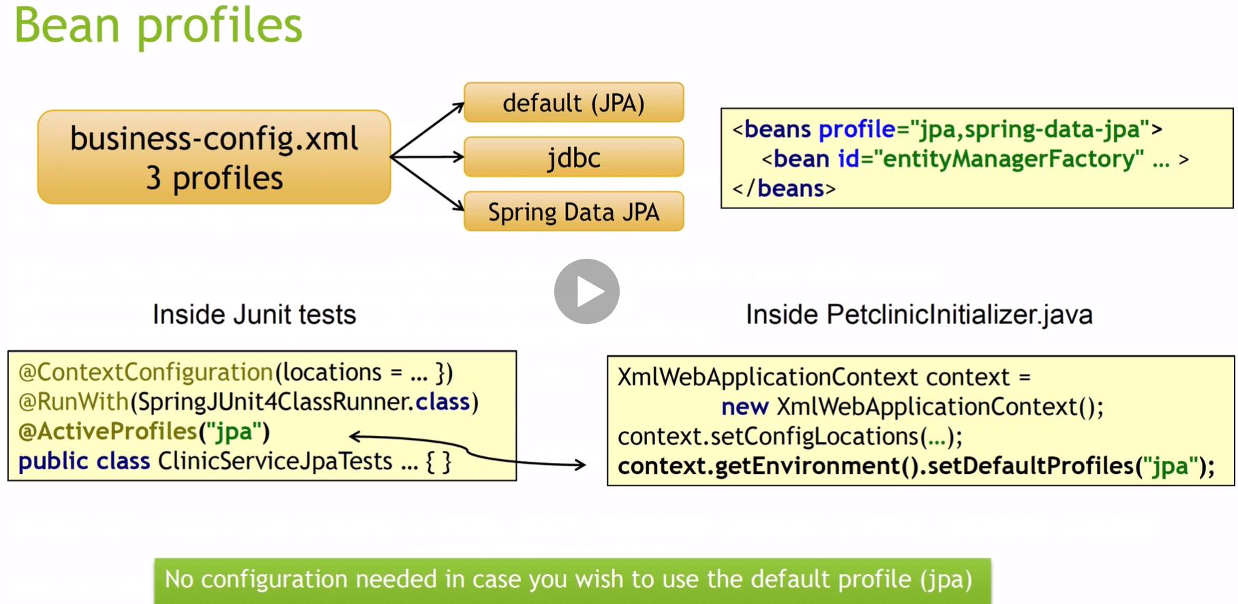

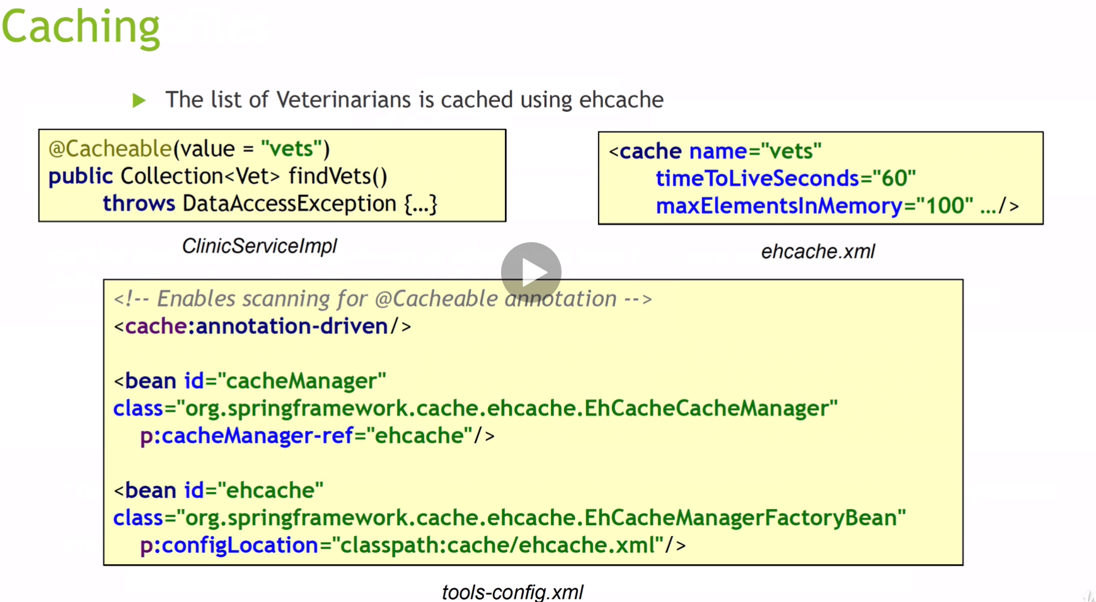

Our setup will not look like the because not to much xml is used in configurations today.

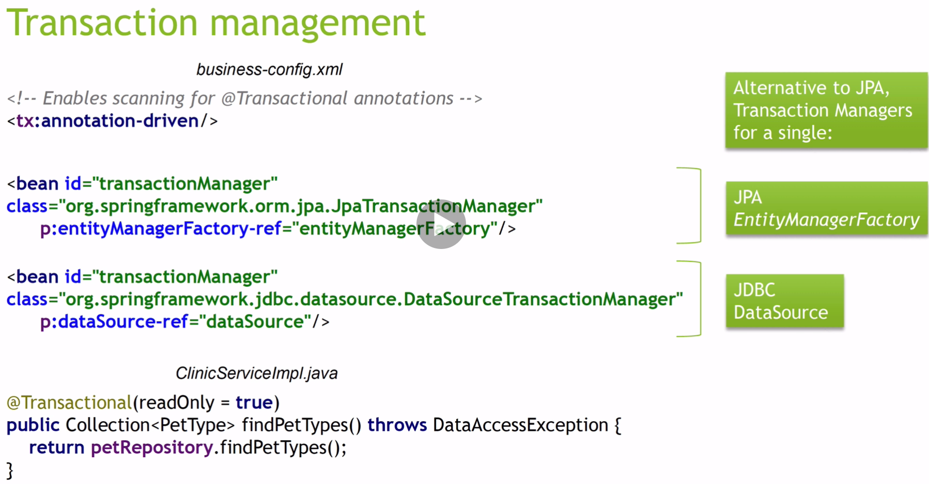

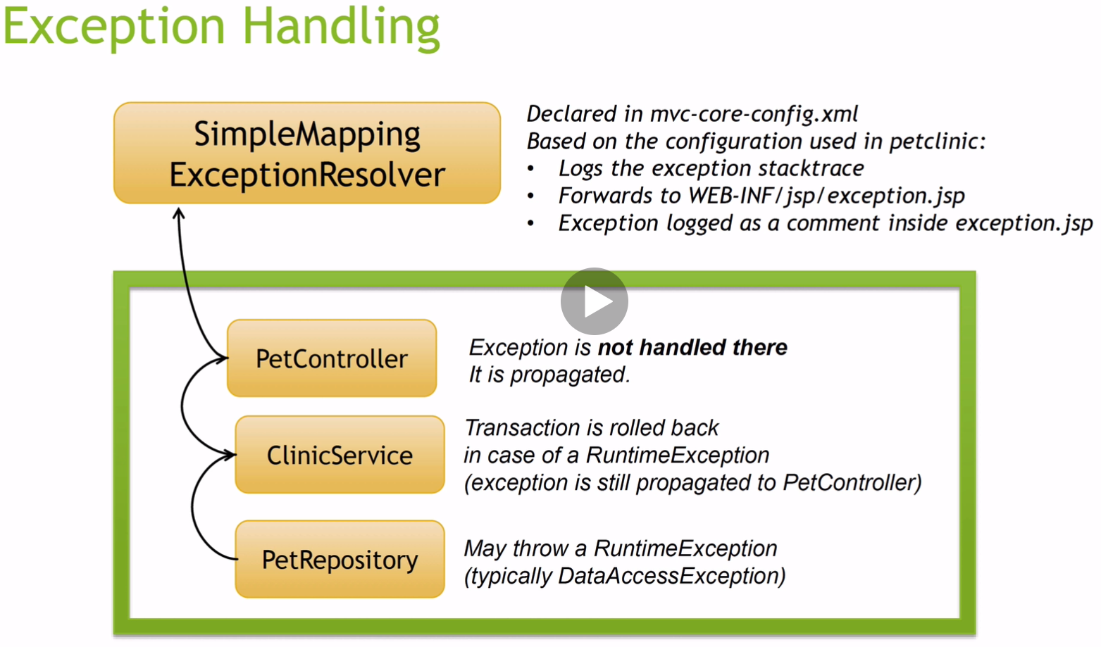

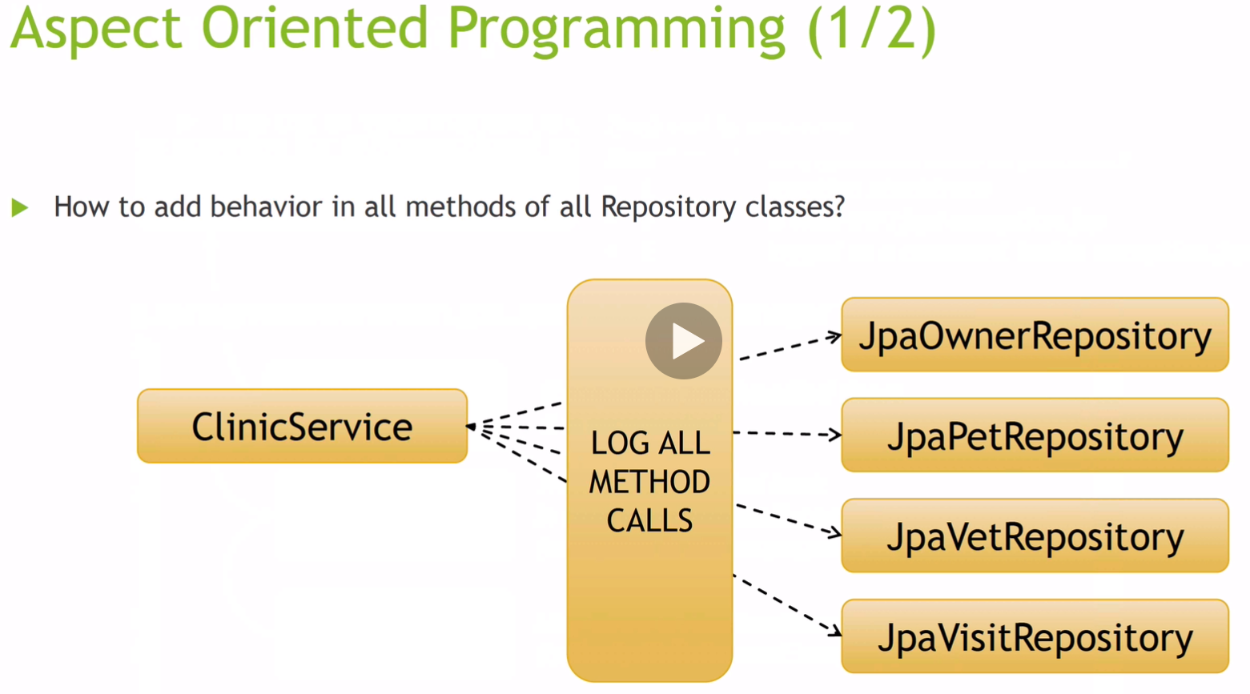

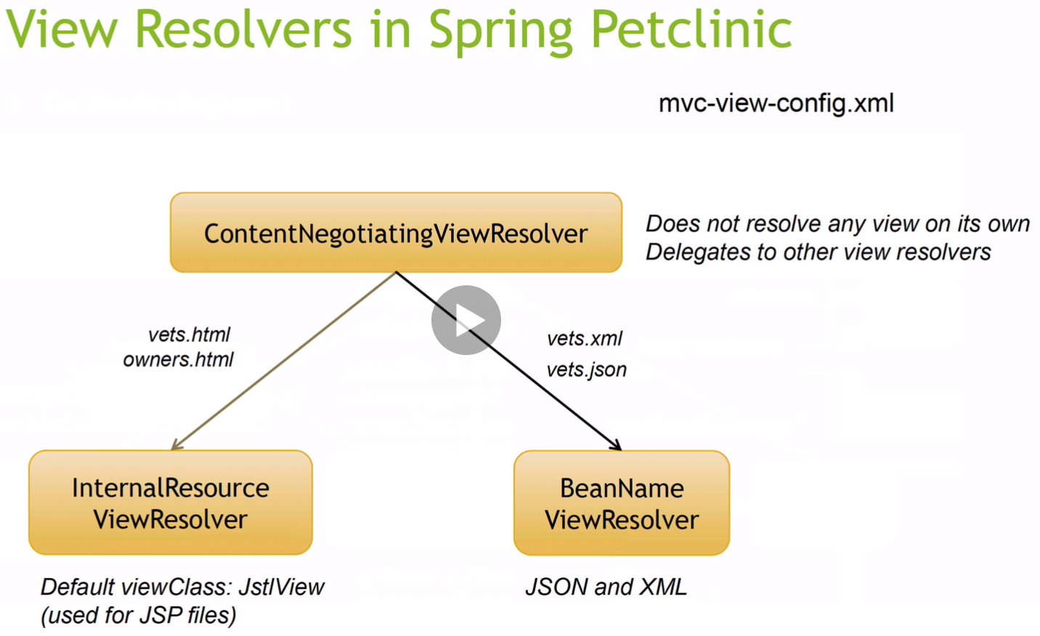

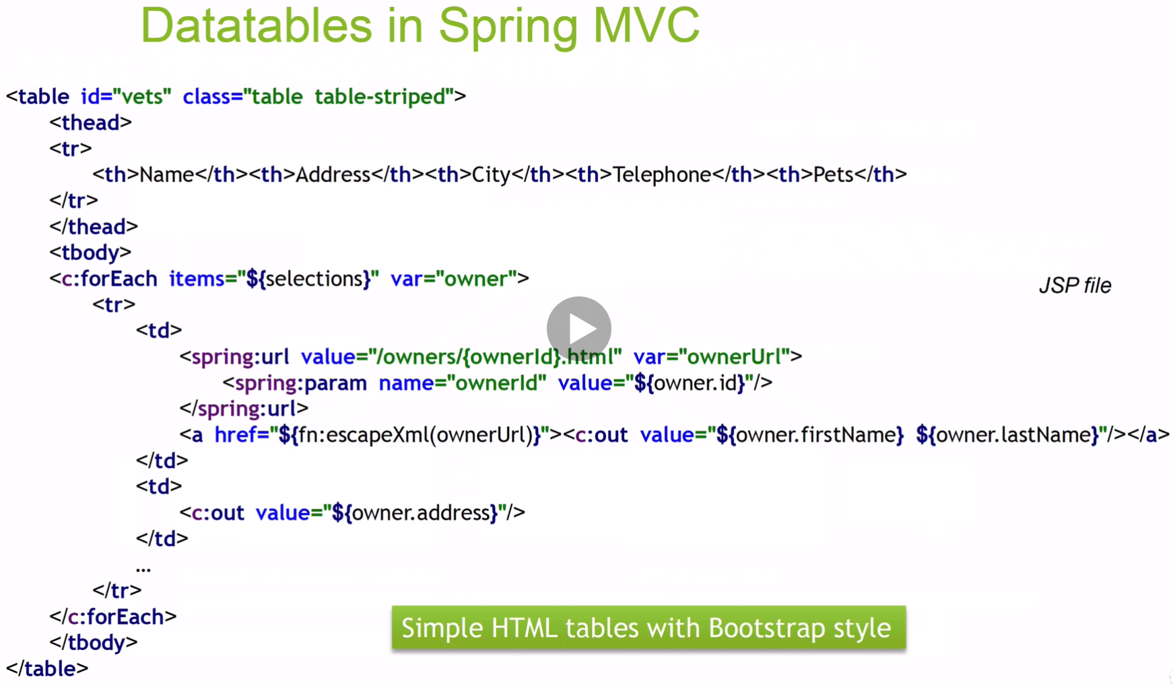

We will be using Thymeleaf instead of JSP.

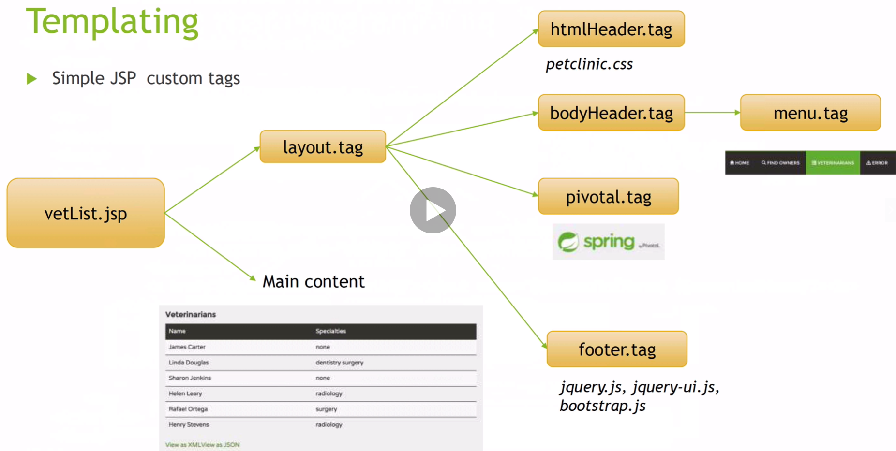

We will be using Thymeleaf instead of JSP.

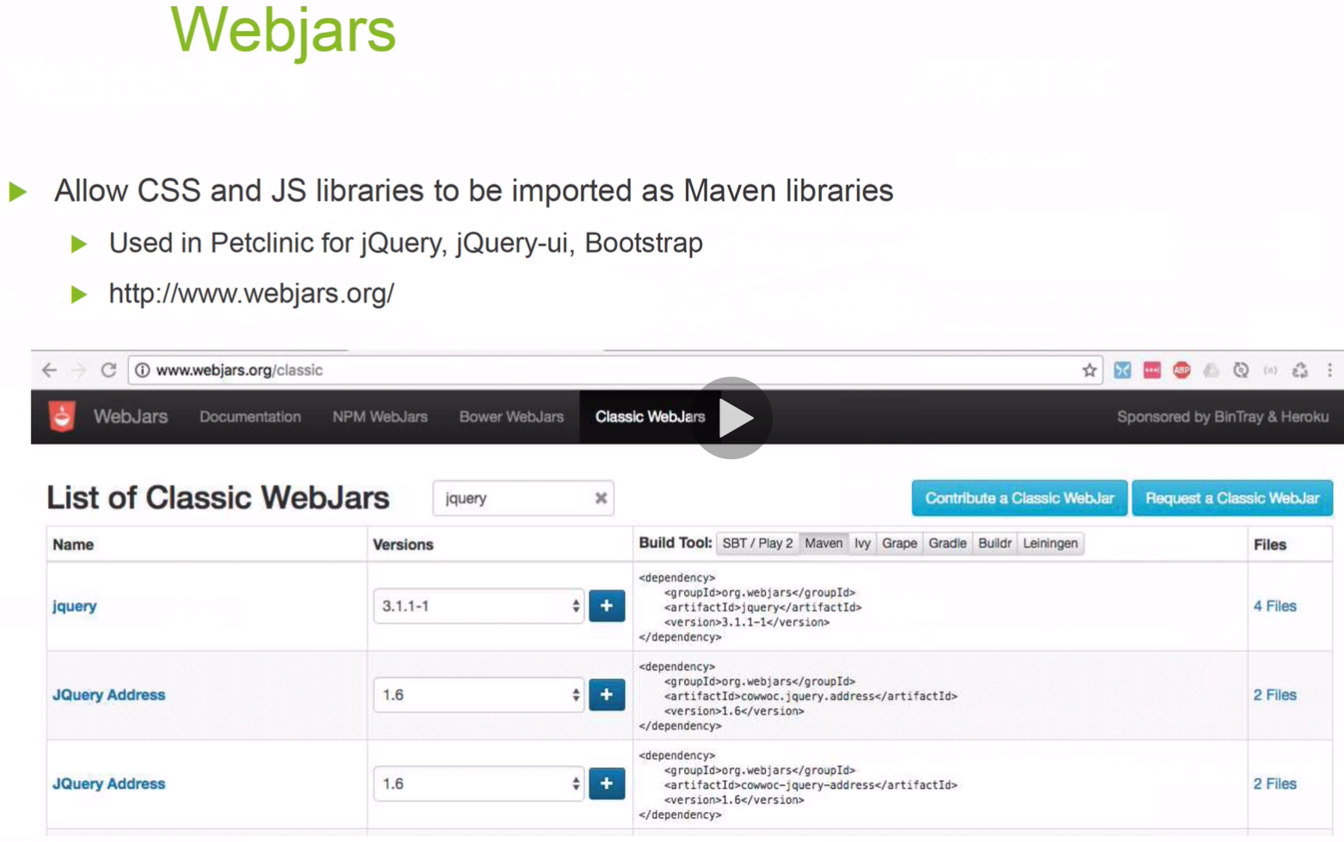

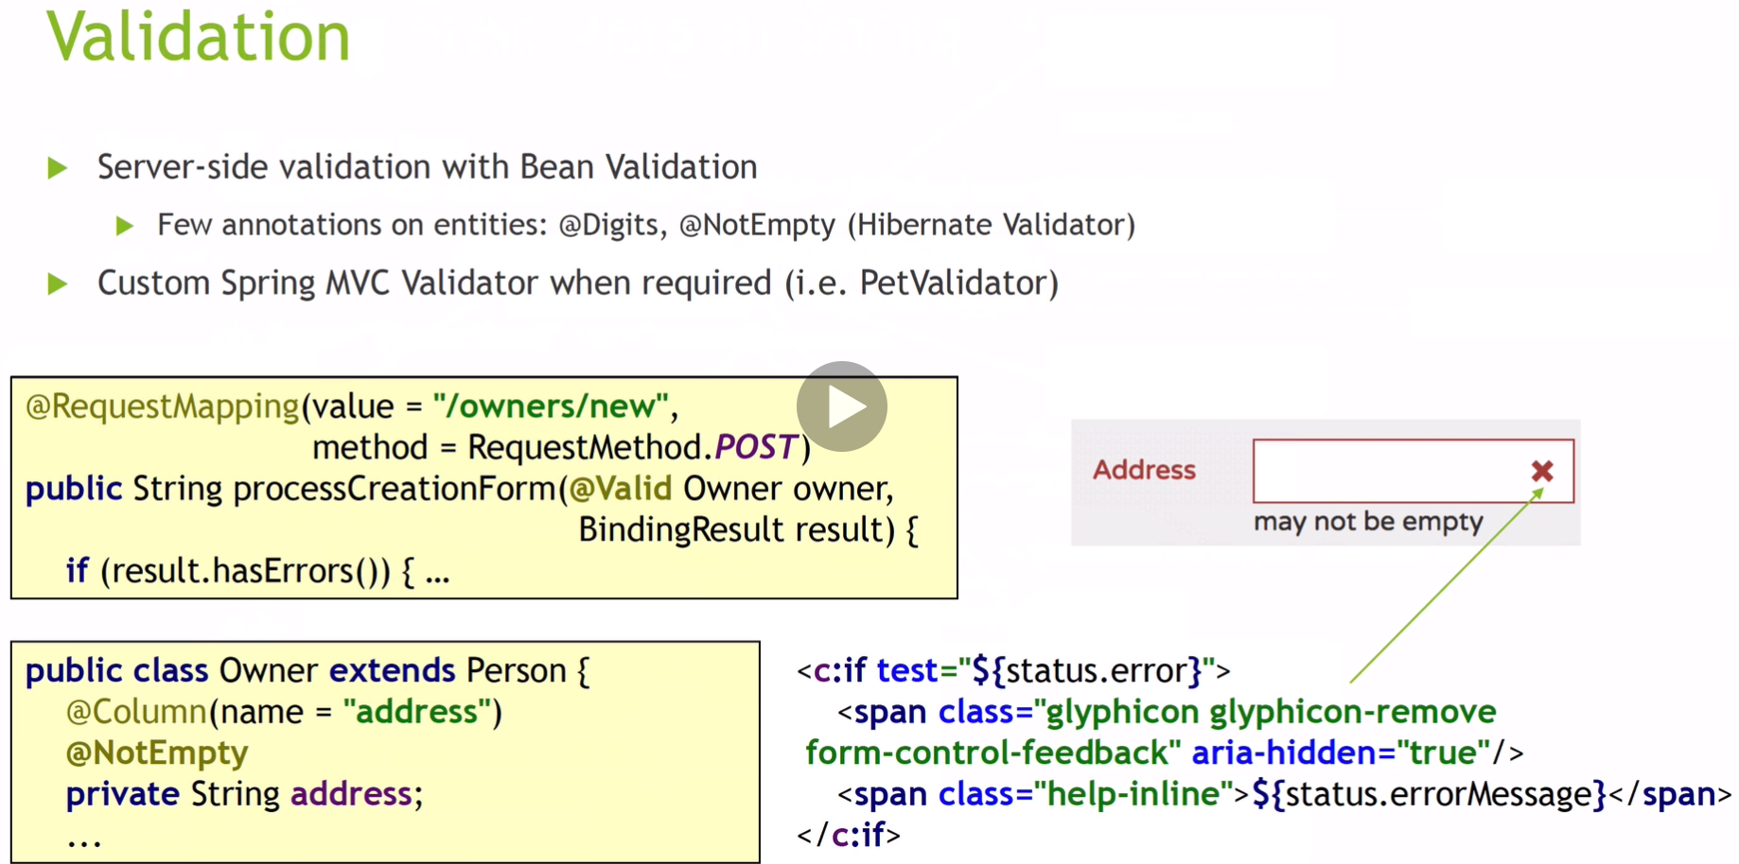

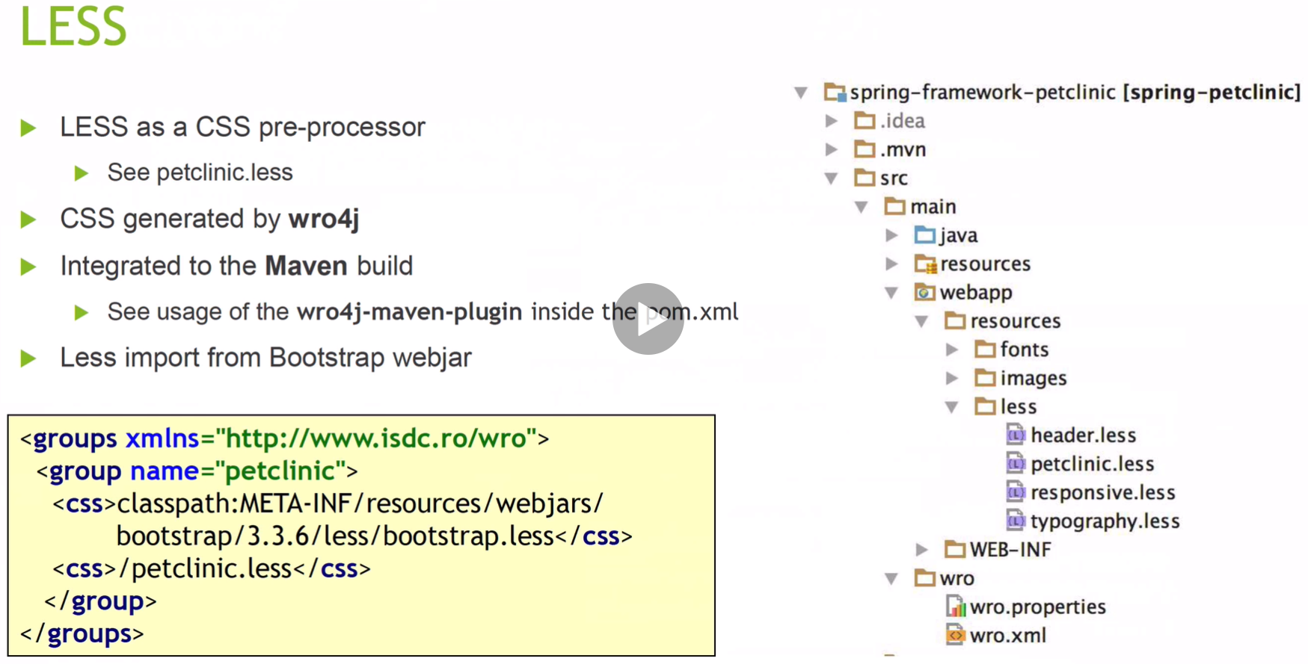

We will not be addressing the Less section.

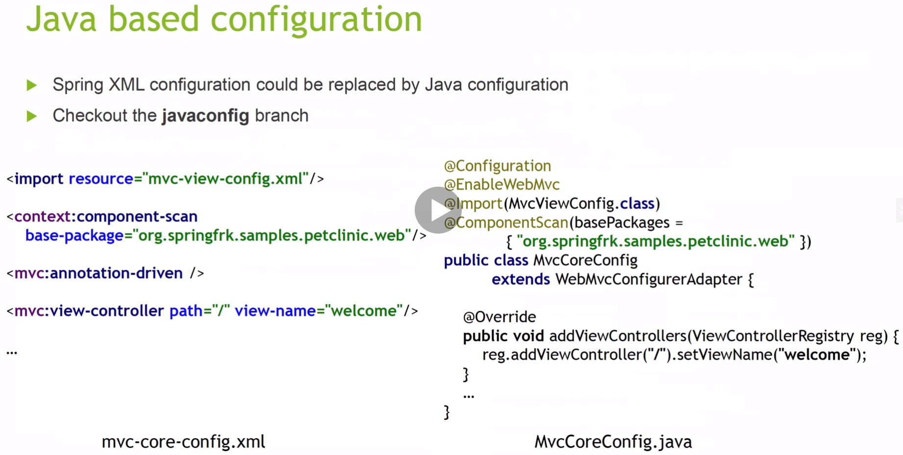

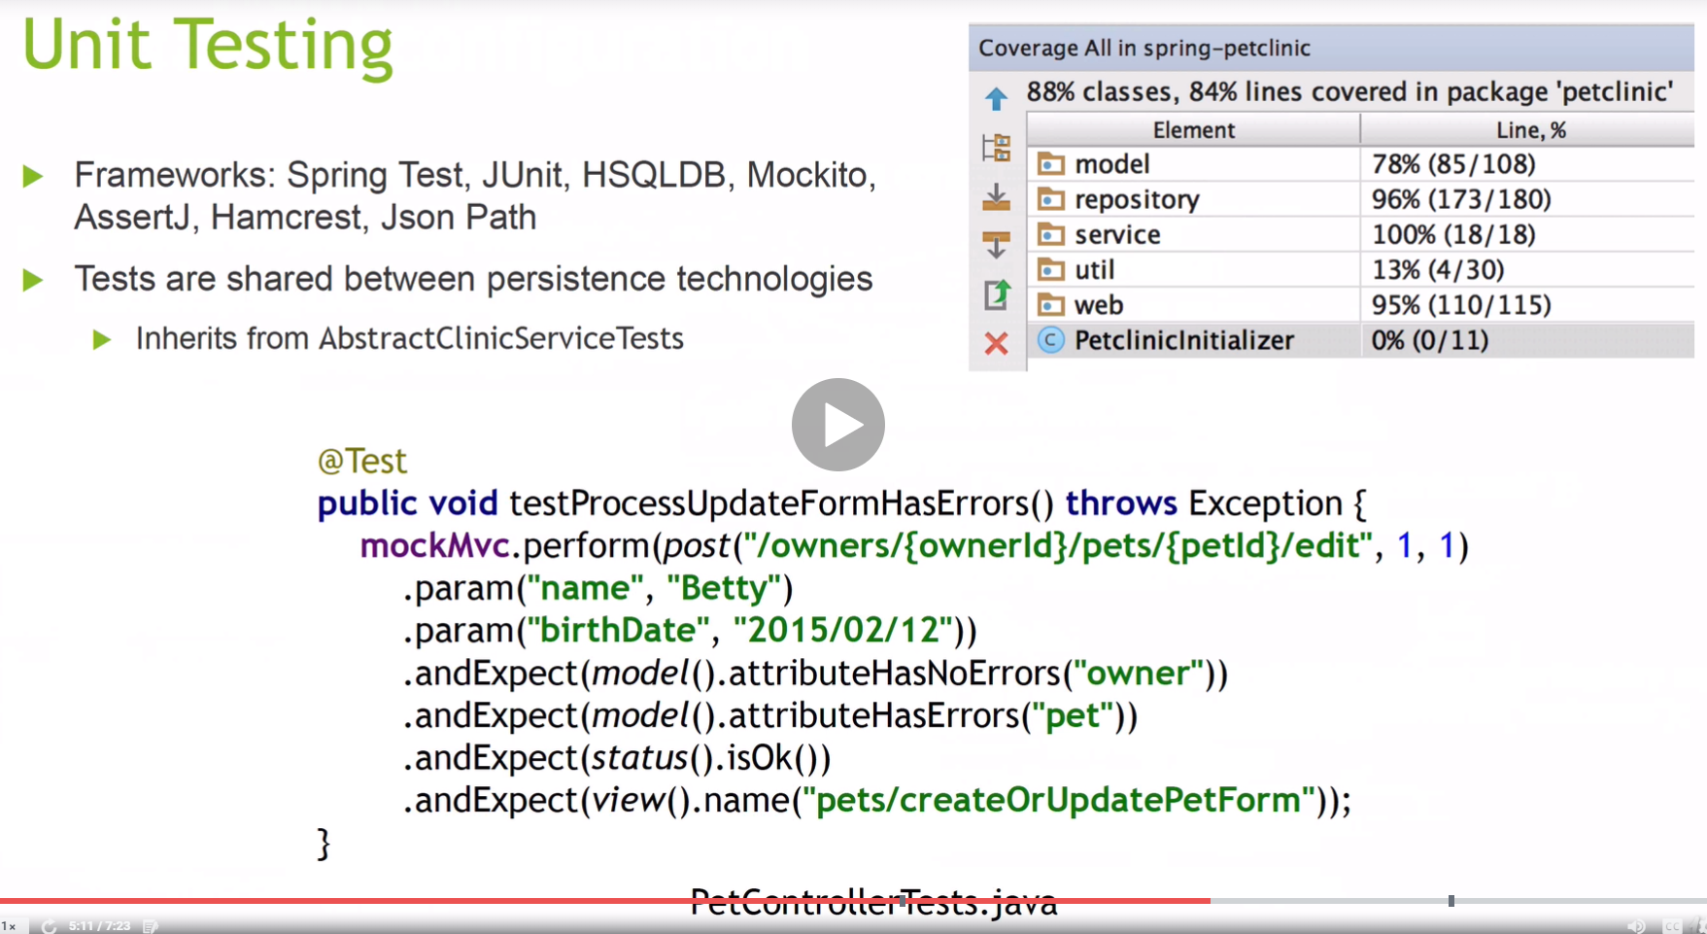

We will be using Junit5 which is the latest version.

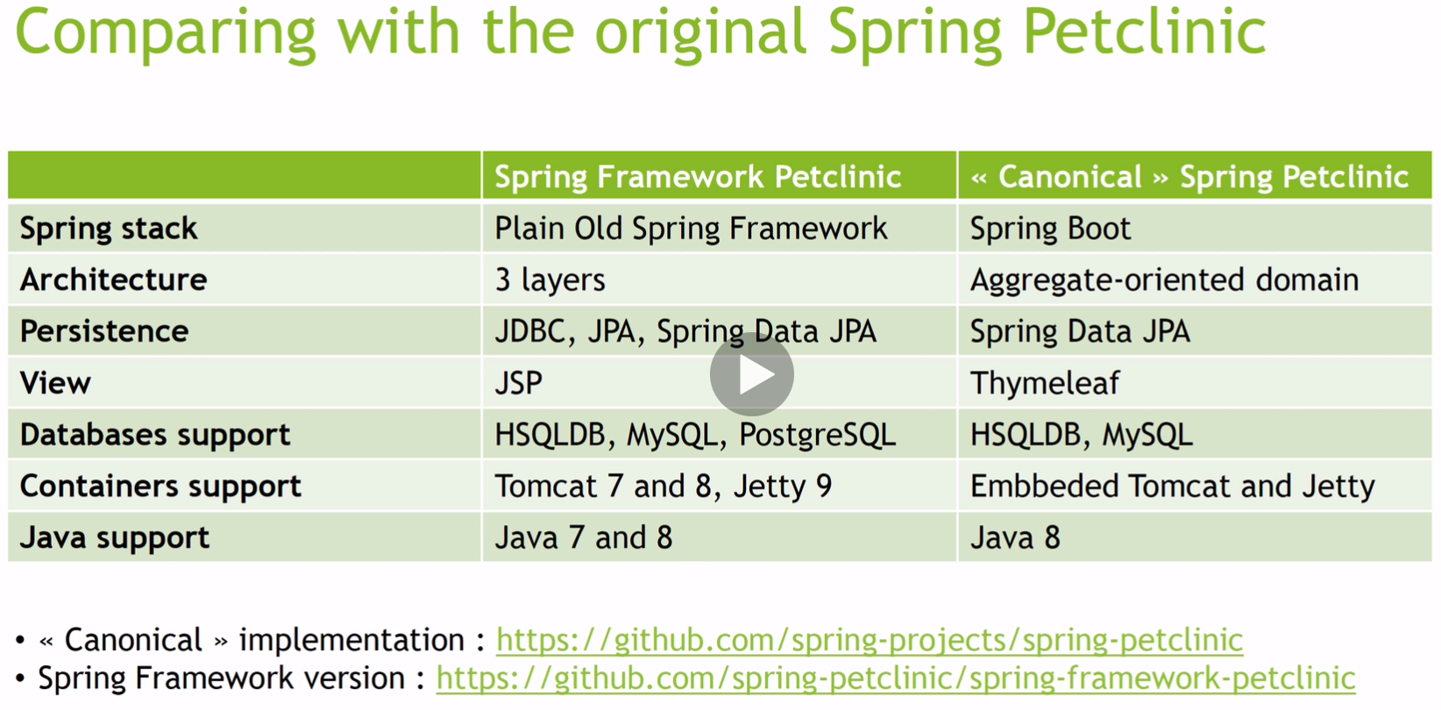

We will be using the Canonical Spring Boot and Spring Framework 5, and not the Plain Old Spring Framework.

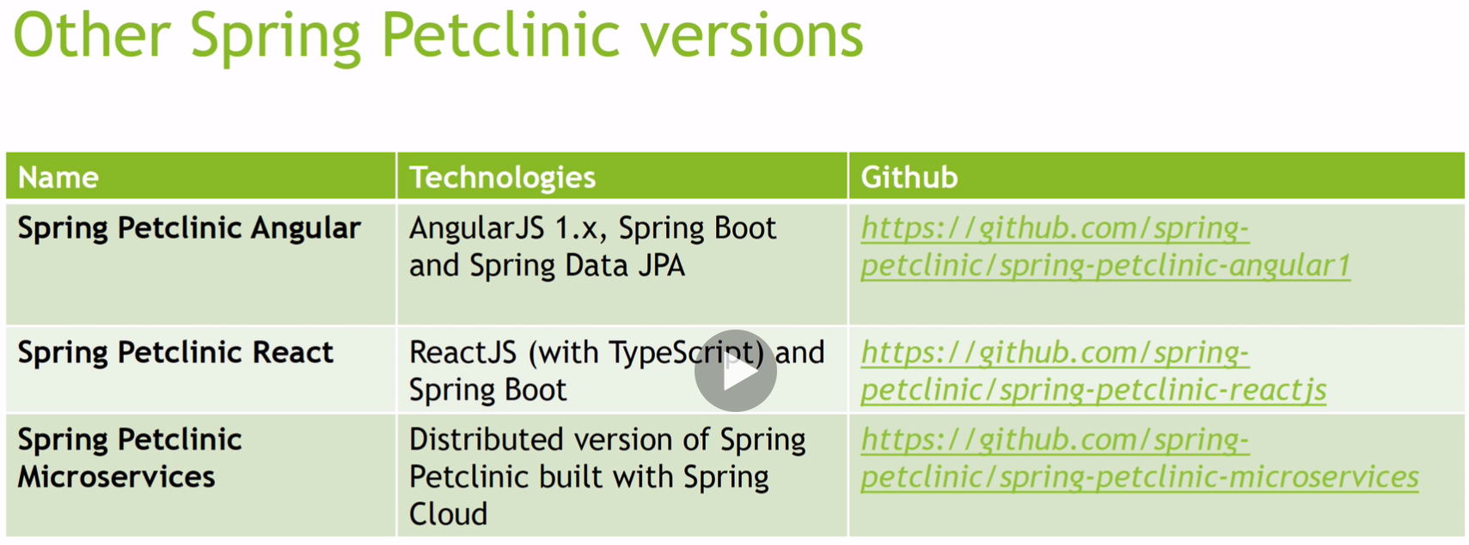

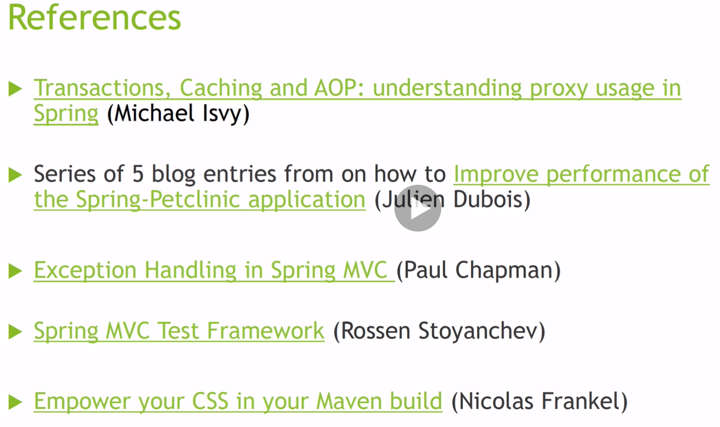

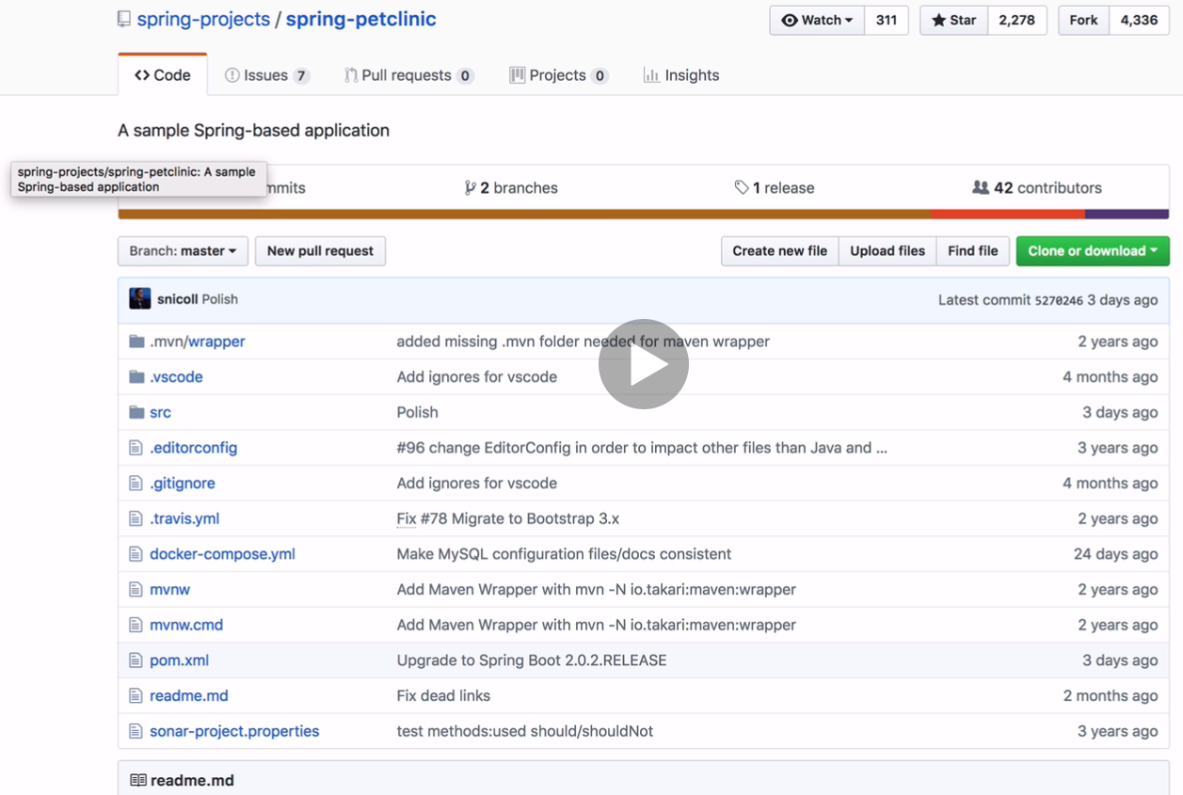

I have forked this down to my GitHub



